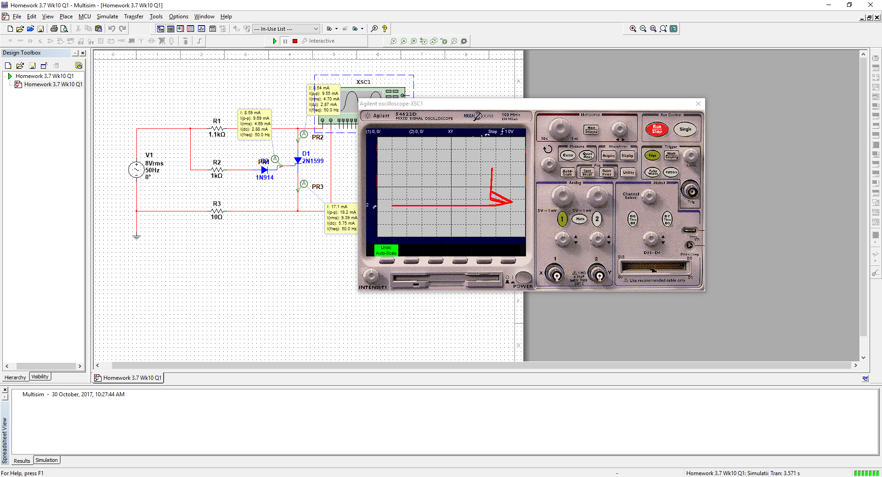

Question 1 SCR current

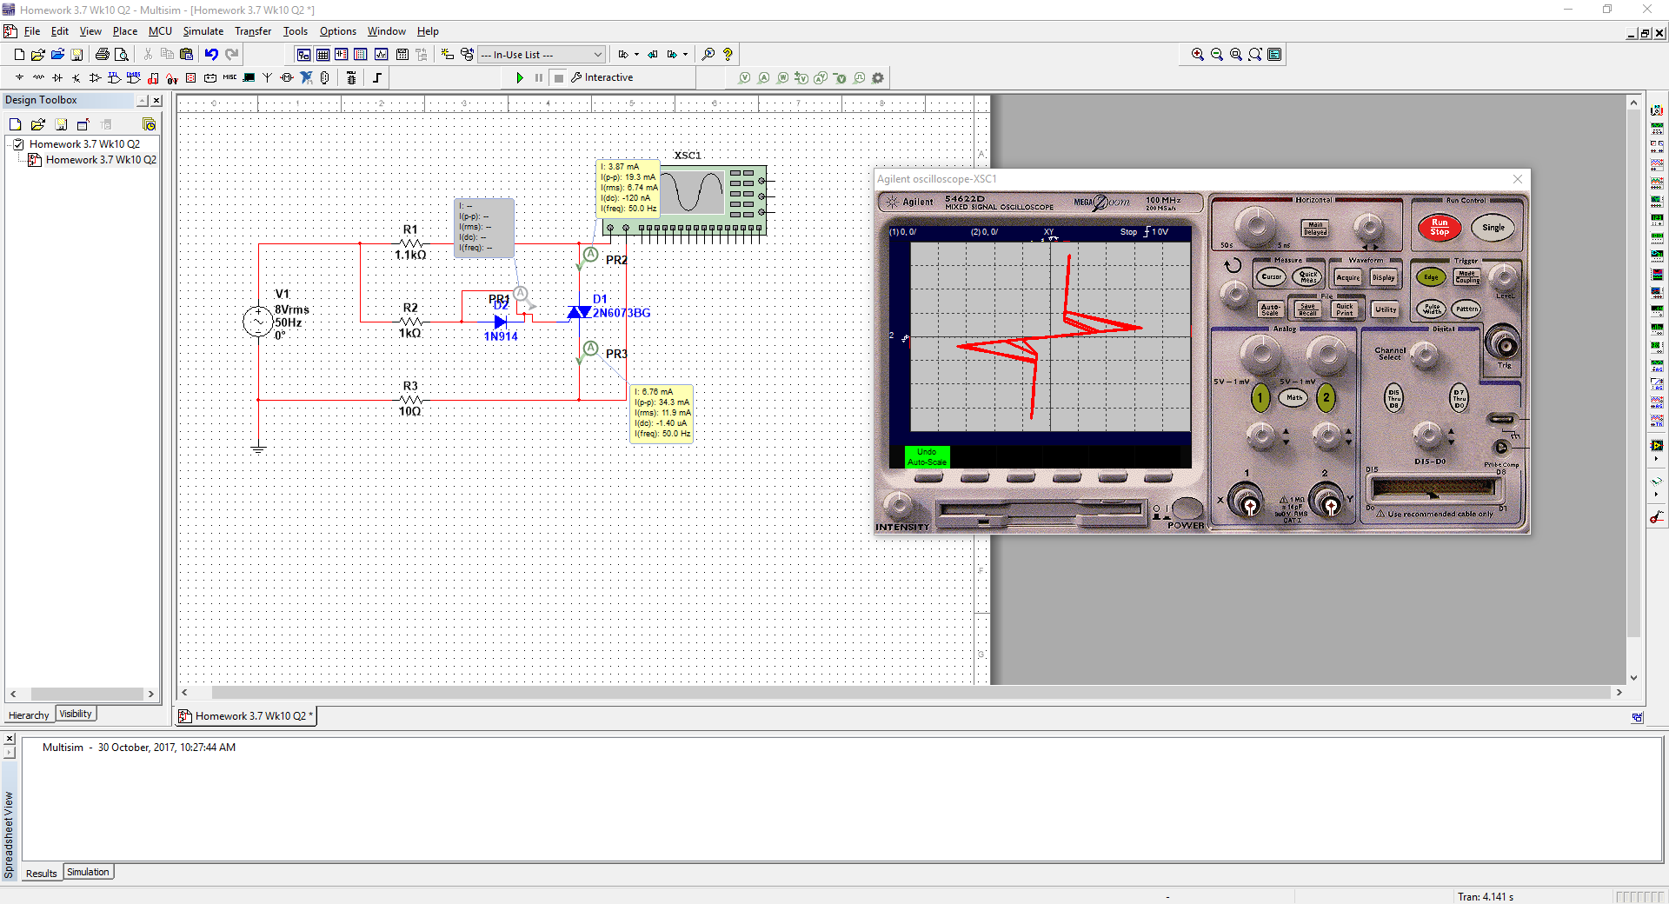

Question 2 triac current

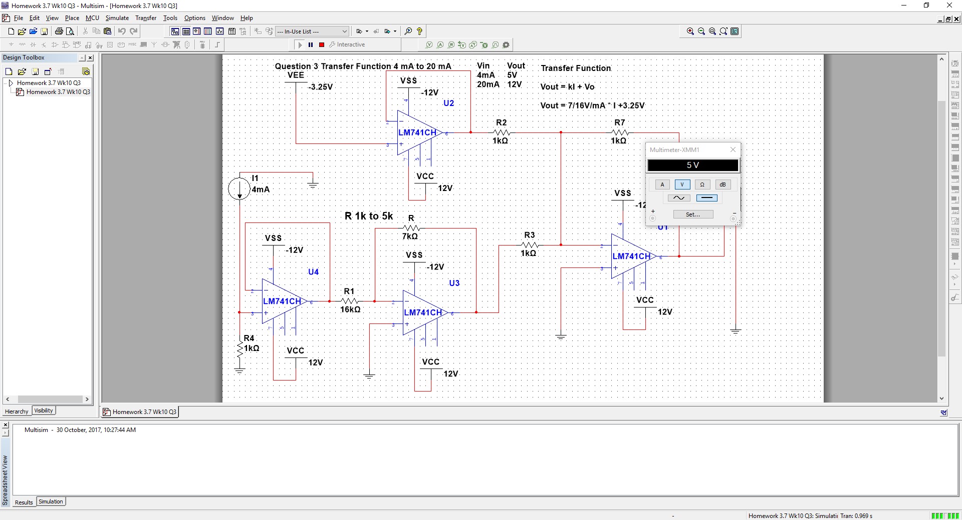

Question 3 Transfer function 4 mA input 5V output

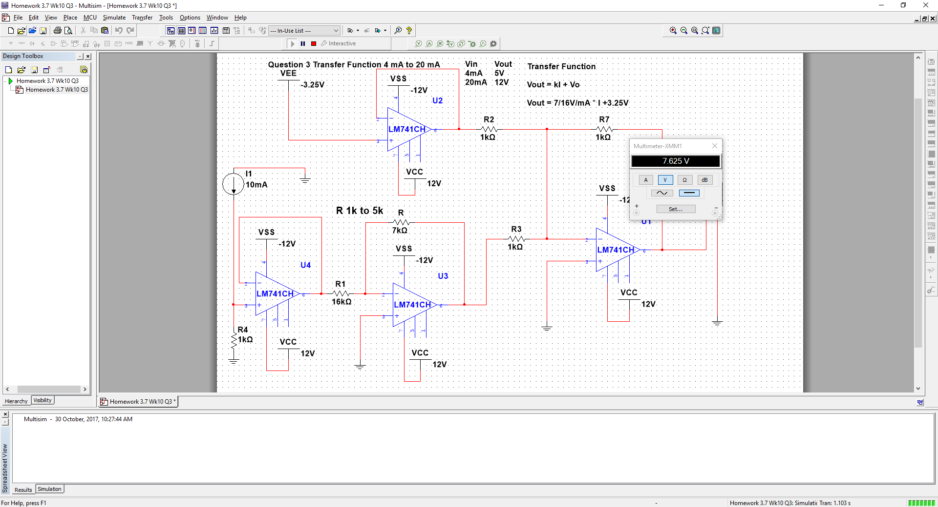

Question 3 Transfer function 10 mA input to 7.625V output

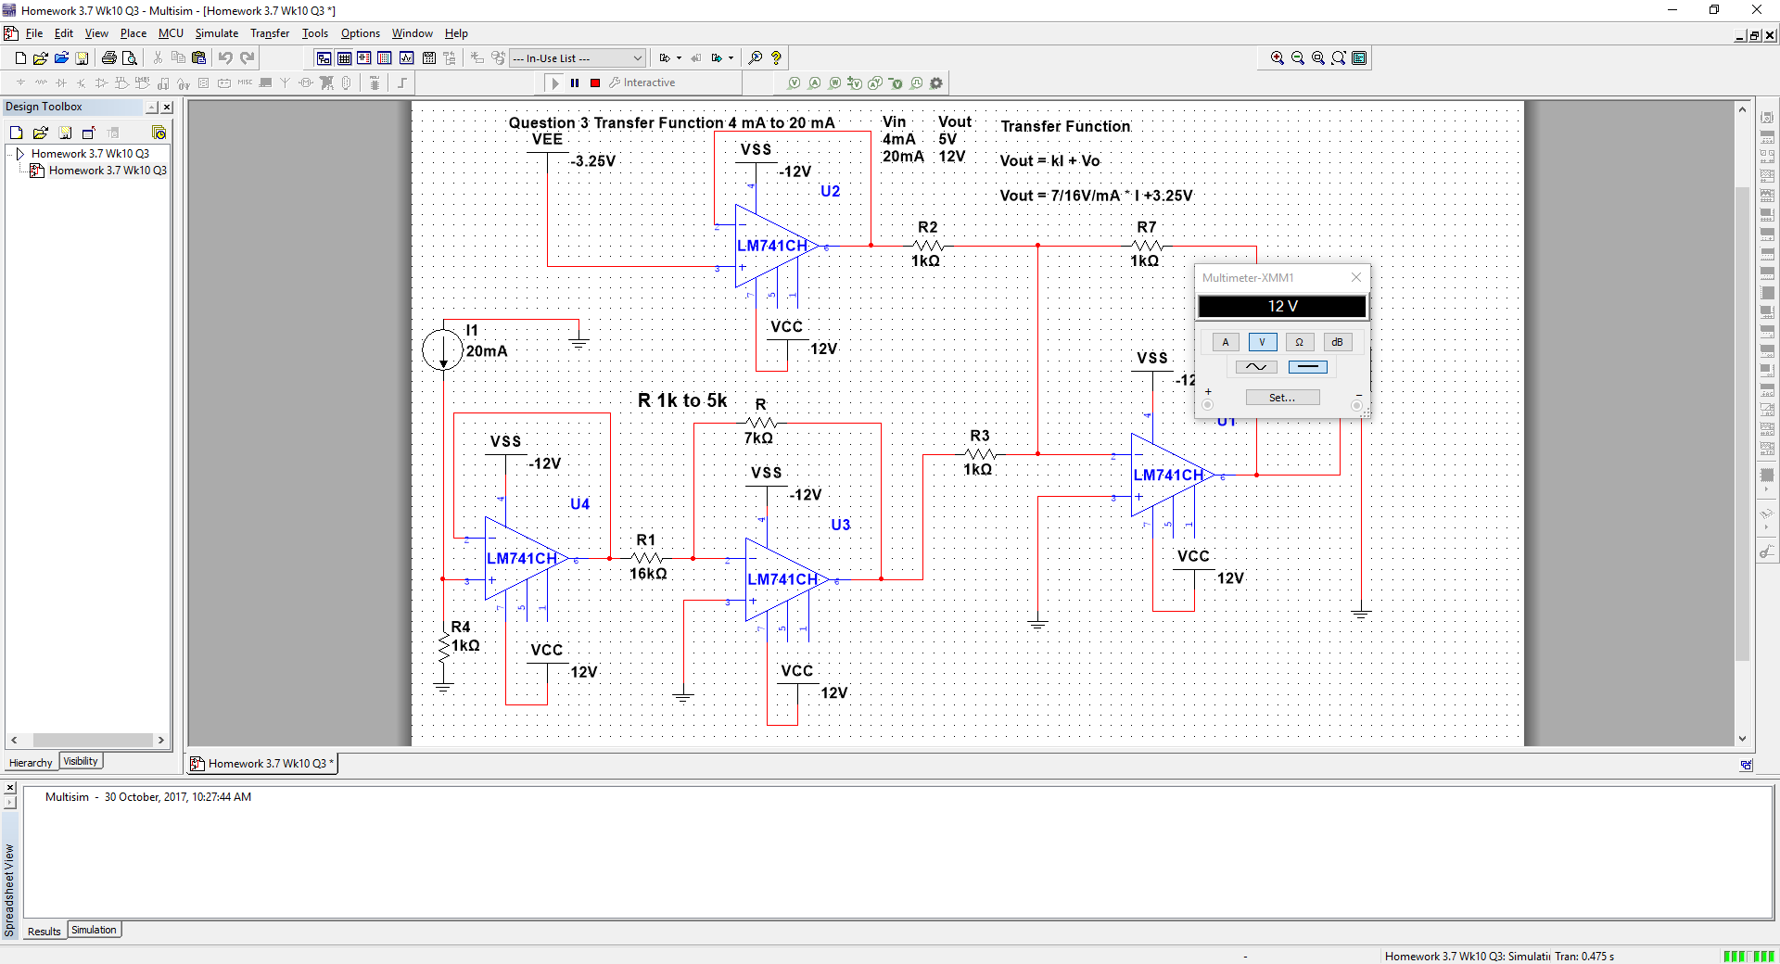

Question 3 Transfer function 20mA input to 12V output

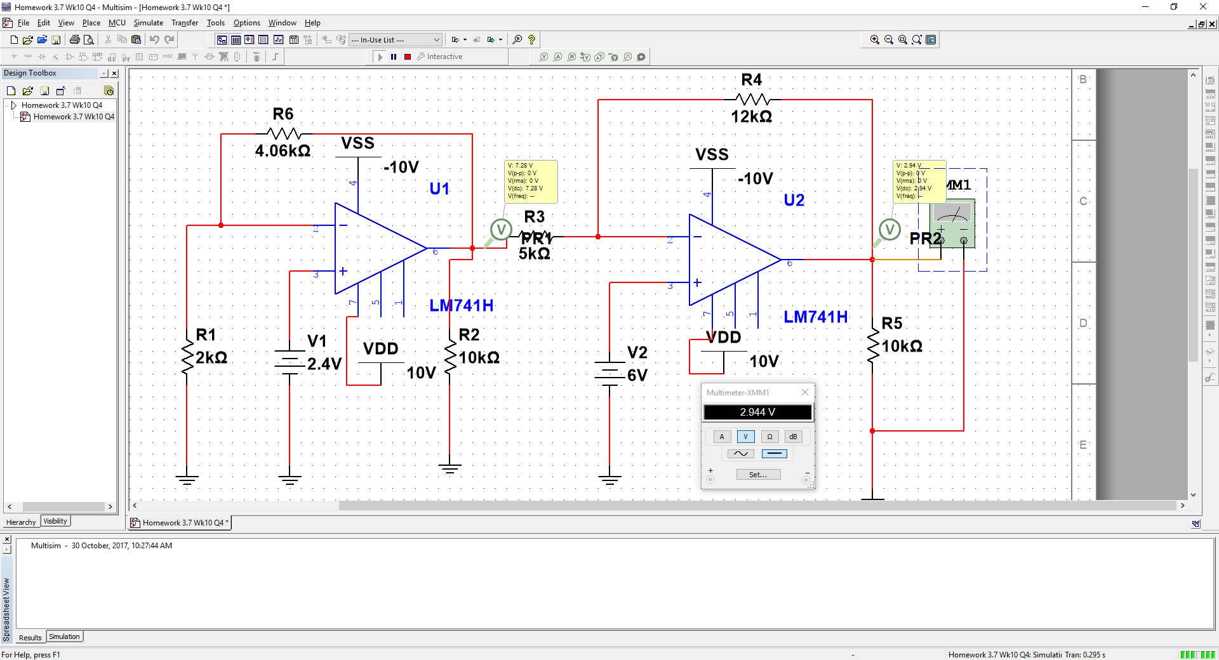

Question 4 temperature 62 degrees Vout 6.9472V

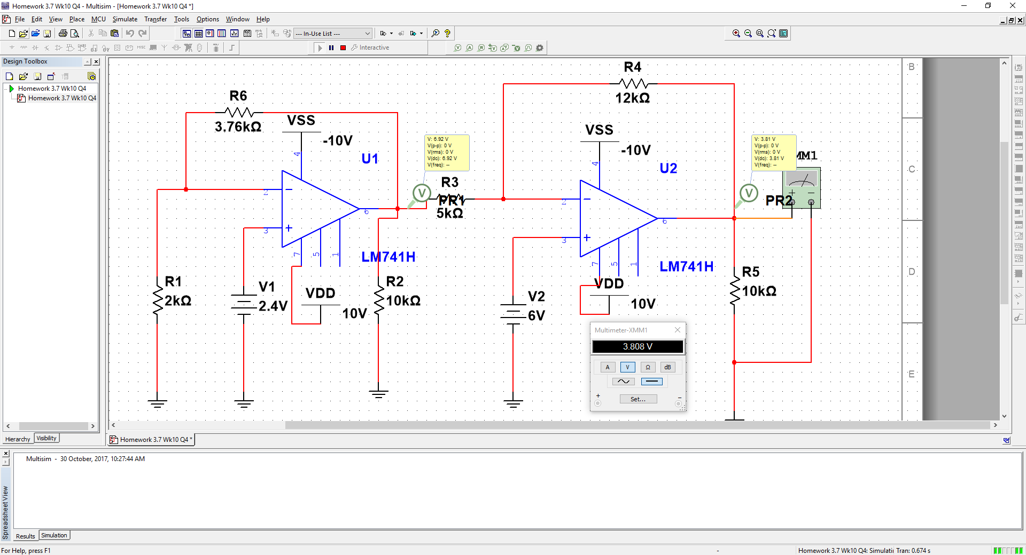

Question 4 when temperature is 52 degrees Celsius, Vout is 3.8112V

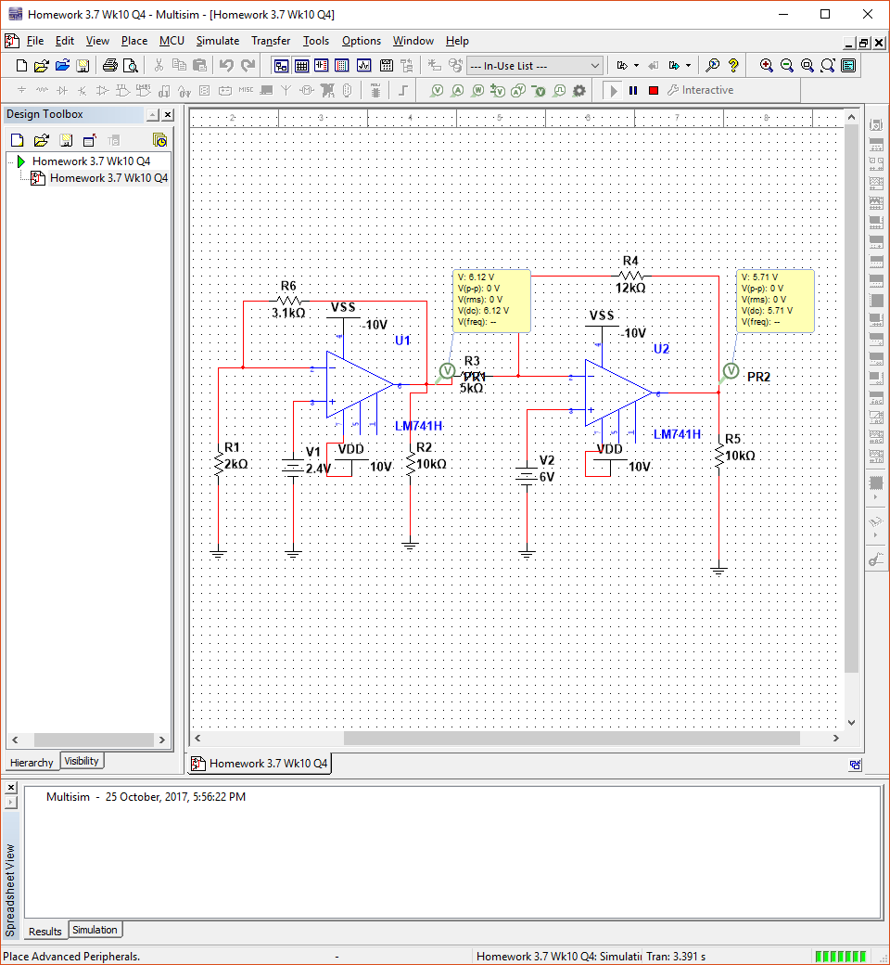

Question 4 when temperature is 30 degrees Celsius

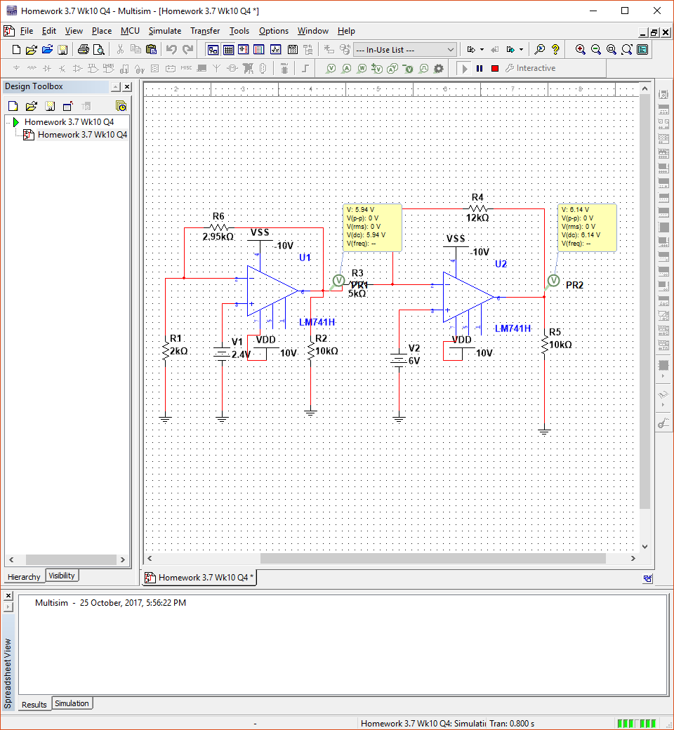

Question 4 when temperature is 25 degrees Celsius

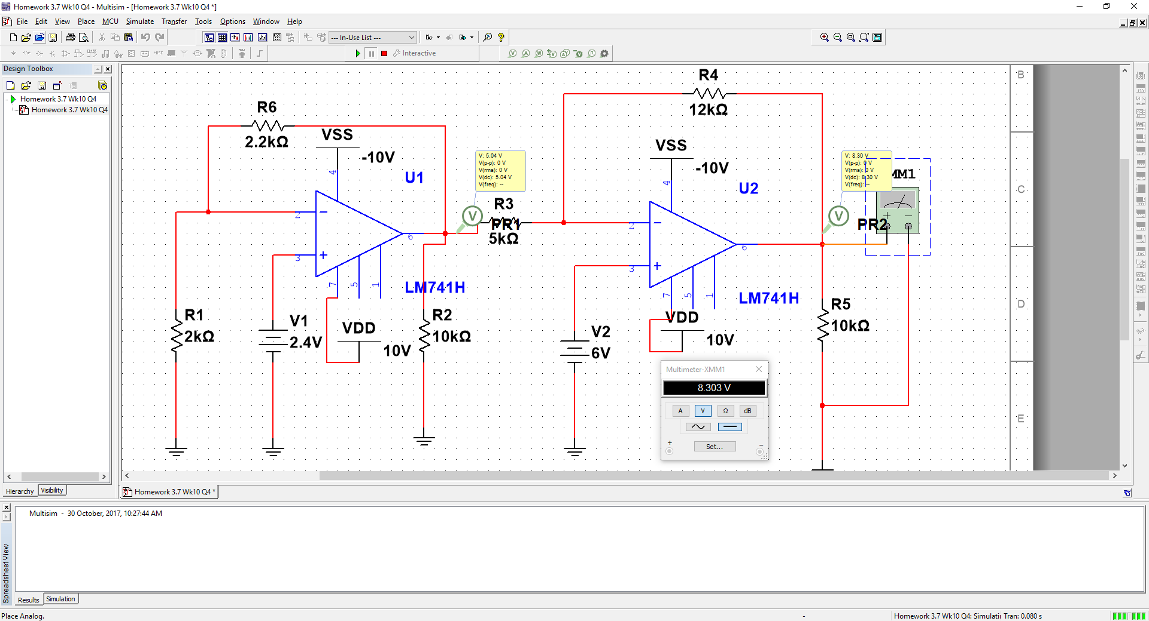

Question 4 when temperature is 0 degrees celcius